DAY2 PROJECT
1. ATM Simulation System
Description
Create a simple ATM program that allows the user to:
- Check balance
- Deposit money
- Withdraw money
- Exit
The program should run continuously using a loop until the user selects Exit.
Concepts Used
- Loop (while)
- Conditional statements (if-else, switch)
- Variables
Sample Output
1. Check Balance
2. Deposit
3. Withdraw
4. Exit
Enter your choice:
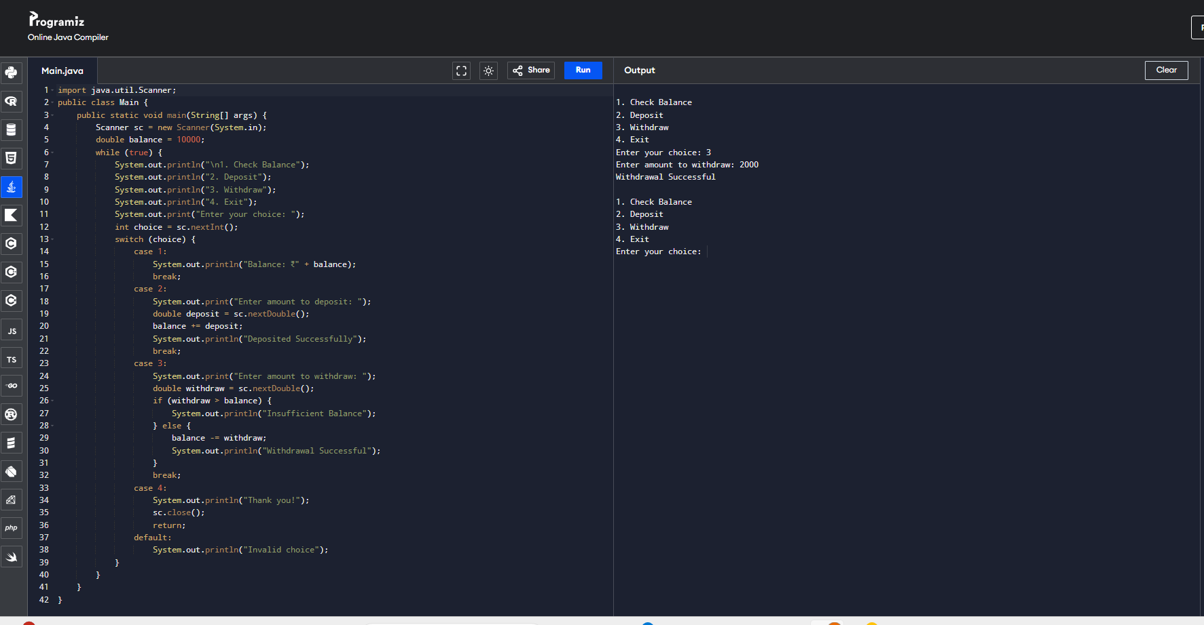

2. Student Result Management System
Description
Create a program that:
- Takes marks of multiple students
- Calculates total and average
- Displays grade (A, B, C, Fail)
Use a loop to process multiple students.
Concepts Used
- Loop
- Arithmetic operators
- if-else conditions
Example Output
Student 1 Average: 85
Grade: A
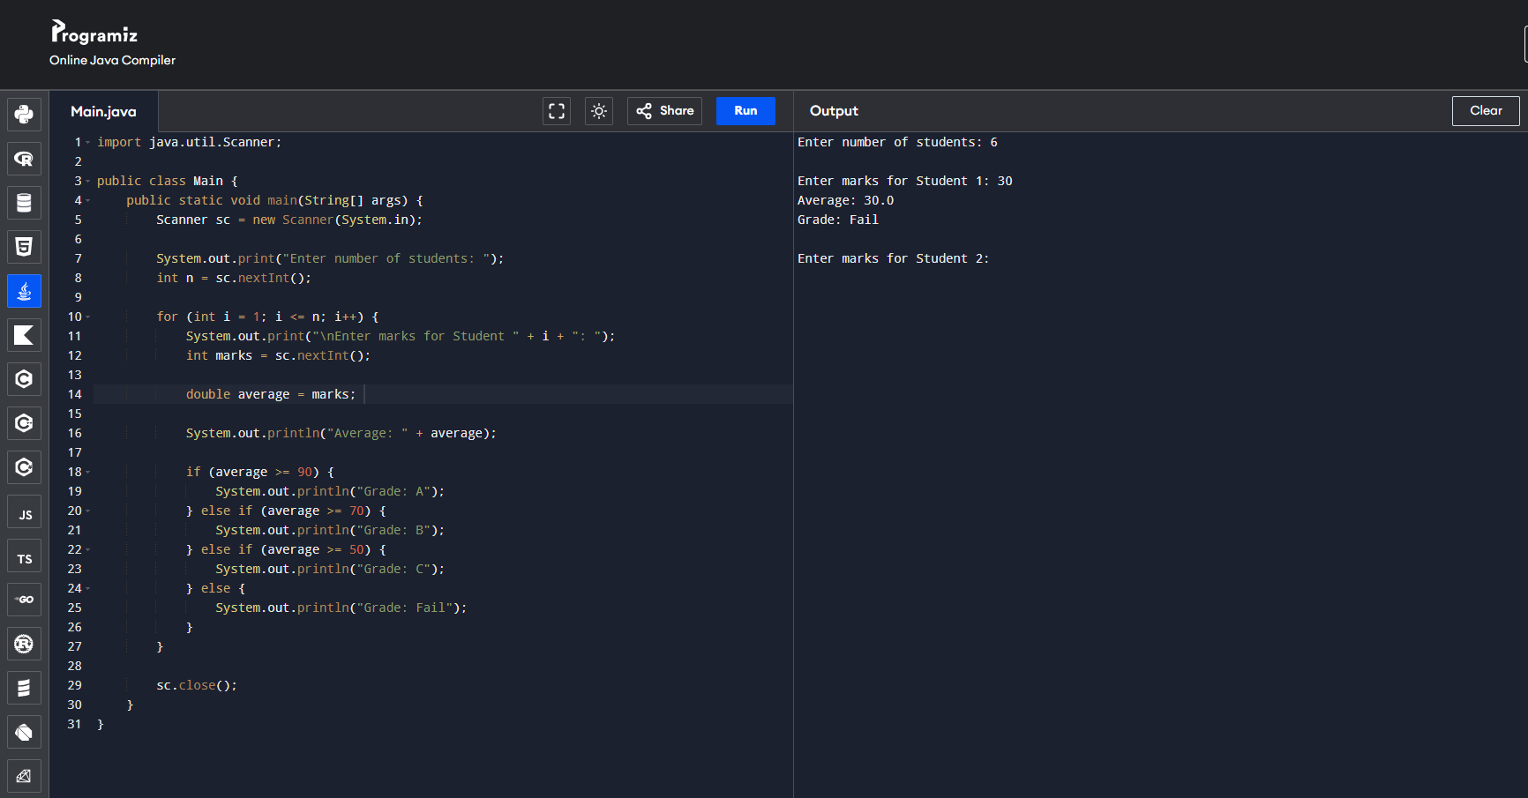

3. Number Guessing Game
Description
The program generates a random number and the user keeps guessing until the number is correct.
The loop continues until the correct number is guessed.
Concepts Used
- Loop
- if-else
- Comparison operators
Example
Guess the number:
Too high
Too low
Correct!
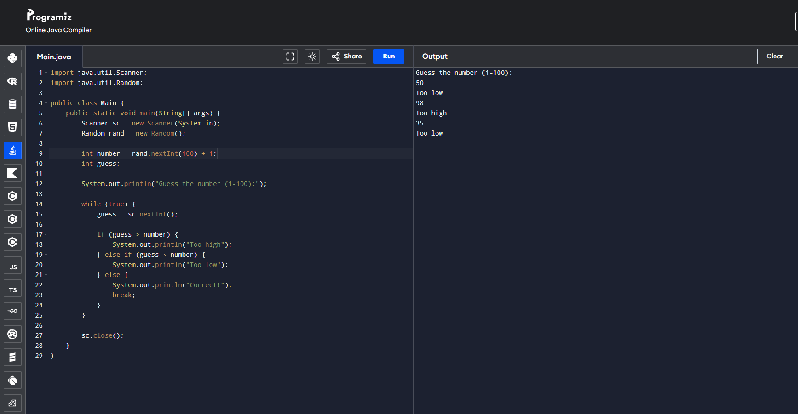

4. Multiplication Table Generator
Description
Create a program that:
- Asks the user for a number
- Prints the multiplication table
- Allows the user to continue generating tables until they exit.
Concepts Used
- Loop
- Conditional statements
- Arithmetic operators
Example
Enter number: 5
5 x 1 = 5
5 x 2 = 10
...
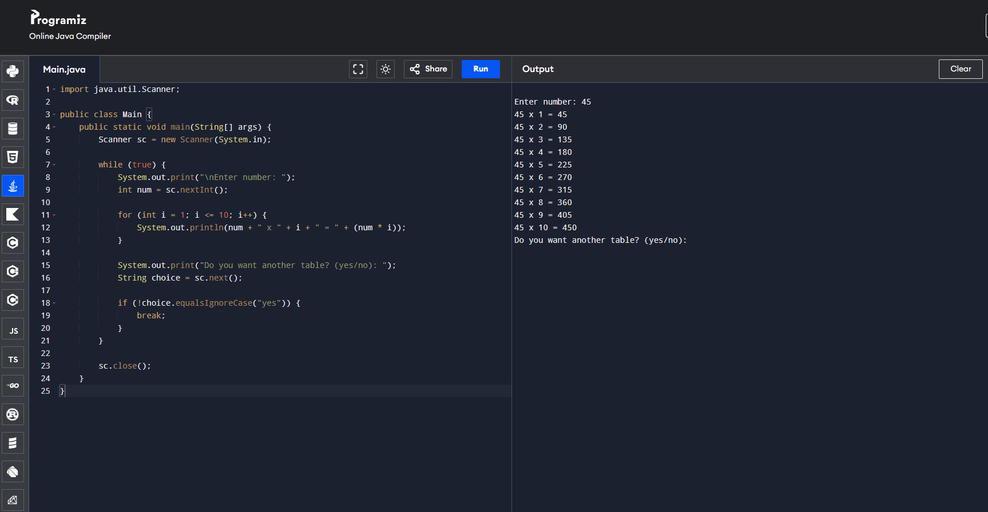

5. Password Login System
Description
Create a login system where:
- User enters a password
- They get 3 attempts
- If correct → login successful
- If wrong → try again
Concepts Used
- Loop
- if-else
- Counter variable
Example
Enter password:
Wrong password
Attempts left: 2
